History:
Originally a nine-bedroom Georgian townhouse built in the 1830s on the footpath leading to Kilburn Abbey, the building was later converted to apartments. In 1931, the apartment has become a major studio
Abbey Road studios is a recording studio located at 3 Abbey Road, St John's Wood, City of Westminster, London, England. It was established in November 1931 by the Gramophone Company, a predecessor of British music company EMI, its present owner. It is most notable as being the venue in the 1960s for innovative recording techniques adopted by The Beatles, Pink Floyd, The Hollies, Badfinger, and others.
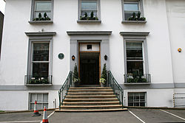
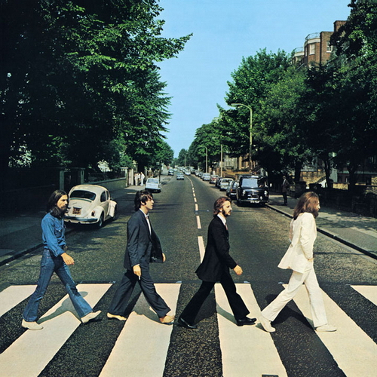
Abbey Road studios is a must see, because it is a very popular music studio. There were many musicians that recording their albums. The most impressive reason is that the Beatles recording their famous album at Abbey Road Studios. They took a picture while the walk at the crosswalk on Abbey Road. That was a impressive photo.

Address:
Abbey Road 3 London

The nearest tube to the Abbey Road Studios is:
Wellington Road, London, St John's Wood
NW8 6DN 6 minutes from Abbey Road Studios.

Opening times:
Studio 2 is open for visitors, but the other studios are not open.
The entrée is free.

